**Kura Labs Cohort 4**

**Jupyter Labs EC2 Quick Start Guide**

1. Log into AWS
2. In the search bar type in and navigate to the “EC2” Service
3. On the left side menu, navigate to “instances”
   1. If the menu is not there, click on the 3 vertical dashes to expand the menu
4. “Start” the instance that was created for Jupyter Labs
   1. Please follow the AWS EC2 Quick Start Guide if EC2 has not been created yet
5. “Connect” to the instance to access the EC2 Terminal
6. Enter the following command in the terminal to download a script that will install Jupyter Labs onto the EC2:

**curl -O https://raw.githubusercontent.com/KingmanT/Jupyter_Setup_on_AWS_EC2/main/jupyter_setup.sh && chmod +x jupyter_setup.sh**



1. Enter the following command to run the script:

sudo ./jupyter_setup.sh



1. Follow the prompts in the script and press “Enter” on your keyboard when asked: “Which services should be restarted?”
2. Jupyter Labs should now be installed on the server
   1. The script will ask if you would like to start Jupyter Lab now. If “yes”, skip to step 11.
3. To start Jupyter Labs, enter the following command in the terminal:

jupyter lab --no-browser --ip=0.0.0.0



1. To access Jupyter Labs, open a new browser, enter the public IP address of the EC2, Followed by port 8888 (<ip_address>:8888)
   1. First time start up of Jupyter Labs will require the entry of a token
   2. The token can be found in the server logs when Jupyer was started. It should look similar to this:

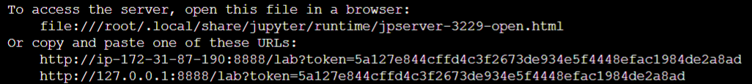

* 1. Highlight and copy the token (4th line in the image above- everything AFTER “lab?token=”) and paste it into the box in Jupyter that asks for “Password or token”
  2. For ease of access, a password can be configured so that a new token isn’t required every time the EC2 is started.